NEW BEGINNINGS

Each chapter that is ending
Leads us to a new beginning.
The past that we are leaving
Means a future we are winning.

Each change that fills the present
Sets the stage for our tomorrows.
And how we meet each challenge
Helps determine joy or sorrow.

In every new beginning
Spirit plays a vital part.
We must approach tomorrow
With a strong and steady heart.

So as we turn the corner
Let’s all apprehension shed.
And fill our hearts with confidence
As we proceed ahead.

Here’s to your new
Beginning . . .

Linda Bailey
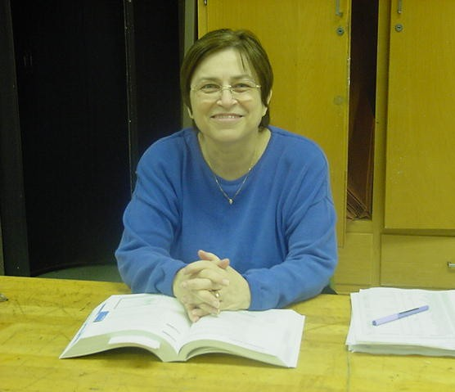
Career background:

Linda has taught for 31.5 years. She has served as Math Chair at HEHS since 1983 and coached the math team for many, many years. She is a past union president and past president of the Illinois Council of Teachers of Mathematics.

A highlight:

Everyday when I am enjoying working with the students and they are “with me” is a highlight. I have been blessed with many special moments.

Miss the most?

I will miss great friends, the super members of the math department, coaching the math team, and the “interesting” politics of District 211. HEHS has the “best” supportive staff. They have made many tough tasks easy.

Miss the least?

I will never miss grading papers.

Retirement plans:

Time will tell. Definitely I will be traveling with my husband.

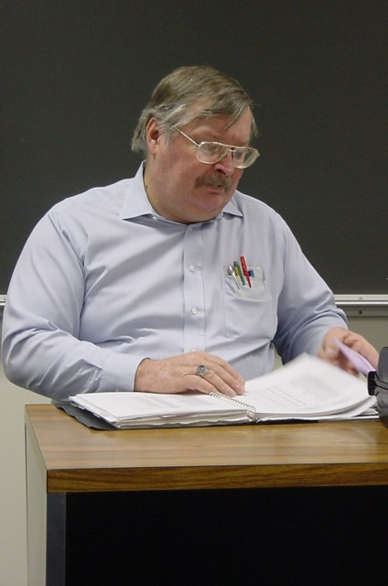

Gary Barker

Career background:
Gary has taught in District 211 for 28 years – 12 at Fremd and 16 at Hoffman. He has taught Survey, U.S. History, AP Government and Economics. Gary has been an assistant coach for wrestling, cross country, track and chess and head coach for girl’s cross country and track.

A highlight:
Winning the IHSA State Championship in girl’s cross country in 1987

Miss the most?
The great colleagues

Miss the least?
The decline in language used in the hallway

Words of wisdom:
The same message for students and colleagues – get involved – it makes the experience more enjoyable.

Retirement plans:
Reading, working on my chess game, some travel

Mary Booker
Career background:
I have been in the district 32 years – 3 years at Fremd – then came to Hoffman when it opened and have been here ever since. I taught Business Ed and Family and Consumer Sciences the first year at HEHS and Family and Consumer Sciences all the other years. I served as Department Chair in 1974 –1984 and then 1988 to the present.

A highlight:
The Hoffman family and the ability to share my passion for children and learning with the students of HEHS.

Miss the most?
The people and the contact with young people. I will miss being in the classroom, using my creativity and love of my subject matter to influence the students.

Miss the least?
Discipline and paperwork

Words of wisdom:
Enjoy what you do – truly what goes around comes around.

Retirement plans:
Still up in the air – maybe move out West, maybe not – whatever. Be involved in my passions of sewing, books, rubber stamping and working with children. Oh yes, I plan to enjoy being a wife at home while the husband works. We hope to travel together and enjoy a slower pace.

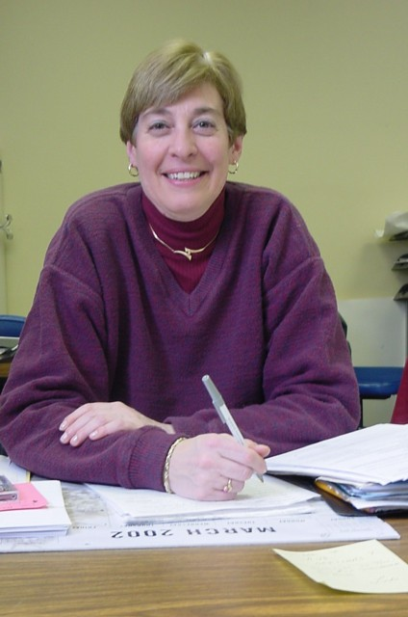

Linda Davis
Career background:
Linda spent 31 years teaching for 211 with the first 2 years at SHS. Taught every level of biology at one time or another, however, usually regular level freshman biology and AP Biology. Taught the gifted education courses since their inception in 1987. As for activities -- science club, senior honors convocation, alumni club and district gifted liaison.

A highlight:
Sooooooo many highlights to choose from, however, one major highlight is knowing that our graduates upon leaving HEHS, have made a good life for themselves and believing I had something to do with their choices.

Miss the most?
Saying hello to all those who work at HEHS, swapping silly stories and jokes in the office, and keeping in touch with former students.

Miss the least?
Receiving half sheets of paper with sad news, waiting for the one stall in the faculty bathroom, deciding which orange and blue outfit to wear on Friday, cleaning dirty glassware, and having to say “put your coat in your locker, take off your hat, and stop running in the halls!”

Words of wisdom:
Listen to the “more experienced” colleagues and ALWAYS be willing to SHARE, SHARE, SHARE!

Retirement plans:
Become the CEO of my life! Use the first year to gauge my “free” time. Included in that year will be golf anywhere I want . . . skiing from my Colorado dream home . . . and start earning my Medicare quarters by being a guest presenter at HEHS in science on Friday treat days. The remaining free time will be kicking back and hanging with friends and family!

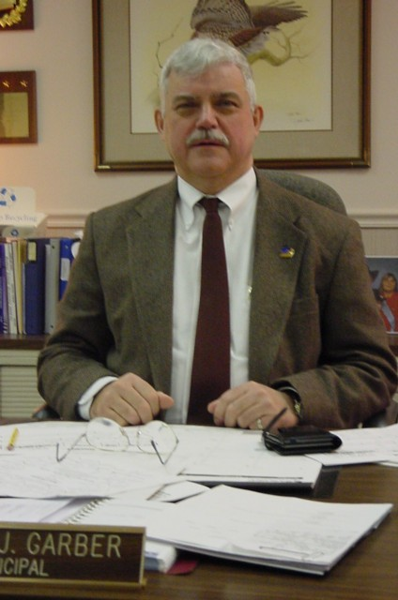

Dennis Garber
Career background:
Denny has spent a total of 37 years in education: 35 in 211 including 4 at Conant, 10 at Schaumburg and 21 at Hoffman. He taught biology and coached football, cross country and track. He was assistant principal at Schaumburg and Conant and principal at Hoffman. Denny was the first head cross country and track coach at Schaumburg.

A highlight:
Hoffman being named the first school in 211 to be nationally recognized for excellence in education. Being named the state principal of the year.

Miss the most?
I will miss the kids and the staff that I have worked with. I will miss all the positive interactions that I have had with staff and students.

Miss the least?
I will not miss the negative interactions (i.e. irate parent calls and major student discipline problems).

Words of wisdom:
Always do what is in the best interests of the students. Don’t be afraid to take a risk. Don’t be satisfied with the status quo. Always be looking for a better way to do things.

Retirement plans:
I plan to spend more time with my wife and five kids, spend much more time fishing, head up the pit crew for my sons who race motorcycles, spend more time working with the church. We will not be moving right away. However, we will be spending more time down South.

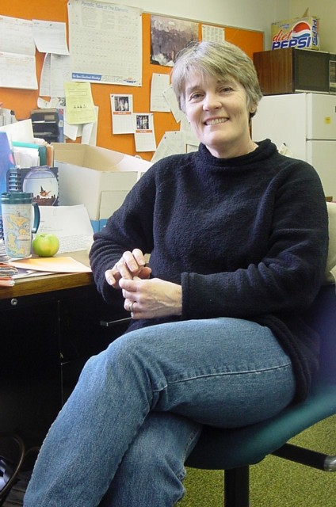

Ann Kjellstrom
Career background:
Ann spent 16 years at Palatine High School teaching Biology, AP Biology and Earth Science. She co-sponsored the Environmental Club. She has taught Physical Science, Earth Science and Plant Science at Hoffman for 17 years. Ann sponsored Horticulture Club and co-sponsored SAVE.

A highlight:
Taking my AP Biology class on a field trip to the Florida Everglades. We raised all the money for the trip by having plant and bake sales!

Miss the most?
All the great people I have had the opportunity to work with – and all the wonderful kids I have worked with in the Horticulture Club.

Miss the least?
Grading papers! Bells! Sharing the restroom with 50 girls during the passing period.

Words of wisdom:
Just remember the world has need of you! Even if no one tells you so, what you do is very important.

Retirement plans:
We hope to travel and spend time in Wisconsin.

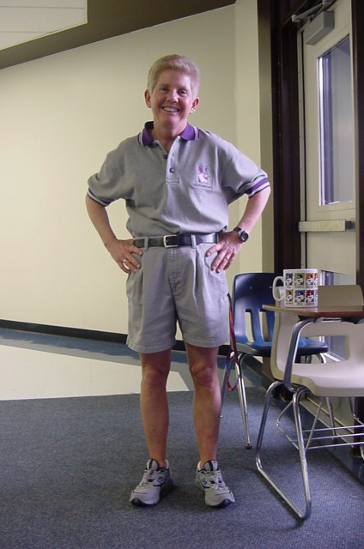

Donna Korda
Career background:
Donna has spent the past 32 years teaching health, physical education and psychology. She has coached badminton, basketball, field hockey, softball, track, volleyball and water polo.

A highlight:
Being asked to open the new Hoffman Estates High School.

Miss the most?
The great majority of kids

Miss the least?
The 3% of the student population causing 90% of the conflicts.

Words of wisdom:
Pick your battles. Ask yourself - “Will this be important tomorrow, next week, a year from now?”

Retirement plans:
Anything I want!

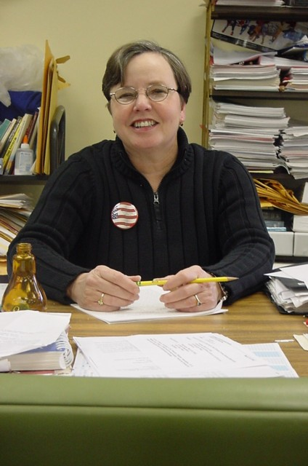

Marcia Nelson
Career background:
My teaching career began in 1964 teaching English at East Campus at Pekin High School. I was a Chink; and Pekin ruled basketball in those years. In 1966, I came to Fremd High School for a two year stint; then I took a few years to begin my family. I returned to District 211 in September of 1974, when Hoffman was in its second year, and here I have stuck like glue.

A highlight:
I was the lucky one who taught AP English; the students were eager learners and fun, respectful young people. My goal was literature appreciation – I’m not sure that goal was accomplished always, but I had fun and was deeply satisfied. Coaching or being the gopher for the Scholastic Bowl team was a highlight as well.

Miss the most?
Without a doubt I will miss my colleagues in the English Department. On a recent birthday, they dressed in purple and wandered into my room, one at a time, or in a group, to present me with a rose and deliver a poetry recitation. I will also miss all the wonderful people in faculty service, the Media Center and A.V., and other support offices who so willingly and cheerfully helped me.

Miss the least?
I will not miss the commotion in the hallways during passing period. Being short, I was frequently stepped on or elbowed. Also, I will quickly forget the steep stairs, grading English themes, and hauling tons of stuff from car to office and back again.

Words of wisdom:
“It’s a great profession if you don’t weaken” - no seriously, it is a great profession, very satisfying with the best people with whom you could ever work. If I were to do it over again, I would take a time management course. Also, I would suggest to any teacher to be yourself. Nothing succeeds with students like authenticity. Feel free to laugh and enjoy the kids’ jokes, even the ones at your expense.

Retirement plans:
I plan to enjoy my life with my husband and married children. I am about to become a first time grandmother; that should be great fun. I can be a child again. Also, Bill and I enjoy our home in Lake of the Ozarks. We recently acquired a boat; we are going to learn to navigate life on calm waters. Ya’all come to see us.

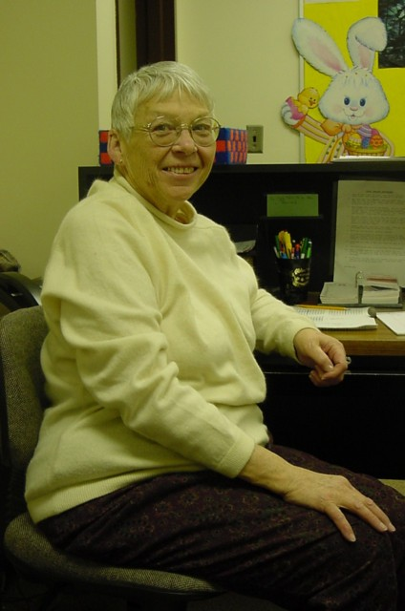

Jan Pawlisch
Career background:
Jan has been at HEHS for 23 years – in the kitchen, as snack line and head cashier, and then test make-up clerk.

A highlight:
Getting out of the kitchen!

Miss the most?
The warmth of the people and the friendships made. I will also miss staying in touch with the youth of today.

Miss the least?
Having to get up while it’s still dark outside on cold, snowy A.M.s

Words of wisdom:
Enjoy it! It can be fun!

Retirement plans:
I’ll take some classes in yoga, water-aerobics and other fun things. It will be nice to be available to travel whenever we want – not just summers and breaks. I may do some volunteer work with animals.

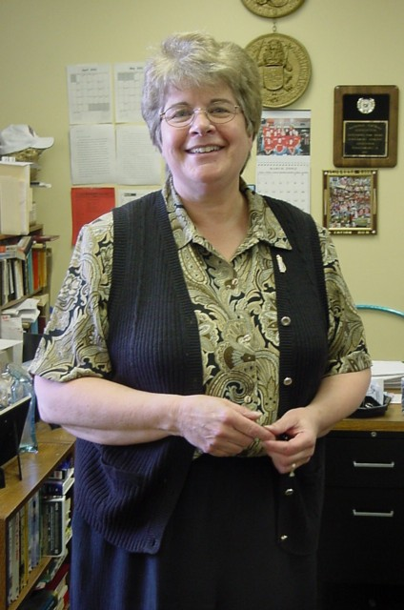

Paula Schofield
Career background:
Beginning in the Chicago school system at Hubbard High School, I was fortunate to work with several supportive mentors. After 3 years I left to begin a new career as mother to my two sons. Then in 1983 I began my association with District 211 as a traveling English teacher at Schaumburg and Hoffman. For the next nineteen years I taught English at Hoffman with creative and energetic teachers. After school I began as cheerleading sponsor and then created Culture Club to give students a chance to experience plays like Showboat and Miss Saigon.
A highlight:
I feel fortunate that my teaching career had a succession of highlights. Witnessing the success of former students brings special pride. Also, my involvement in the gifted program challenged me and stimulated changes in my teaching techniques and curriculum choices. I enjoyed working with the free-spirited students and teachers in the program.
Miss the most?
Most of all, I will miss my friends at Hoffman. As a social being, I have always enjoyed the intellectual debates, animated discussions and sensational practical jokes over the years. My English colleagues are very special to me and are responsible for making work a fun place. Recently, when I broke my ankle, they all rescued me by helping with hundreds of tasks and constantly giving me moral support (after they wildly embellished the details of my accident).
Miss the least?
Our second floor pea-green carpeting is one of the few things that I will not miss about Hoffman. Also, I will definitely not miss waking up at 5:20 A.M. to get to work on time.
Words of wisdom:
I have no words of wisdom, but I do want to share some ideas for survival. Every day look for something to bring you joy and a reason to praise your students. Be sure to make time to play and always keep your sense of humor.
Retirement plans:
Retirement will be a time to reconnect with a playful attitude toward life. I will spend extra time with Griffin, my grandson, and unlock the wonders of his world. Also, Bernie and I are looking forward to traveling to new places and sharing good times with our sons, Jim and Steve and Steve’s wife, Carolyn. Golf, of course, will continue as an obsession, and I will find constant excuses to be out on the links. Finally, I plan to give time to charitable organizations that tape record textbooks for blind students and offer relief to primary caregivers for the sick.

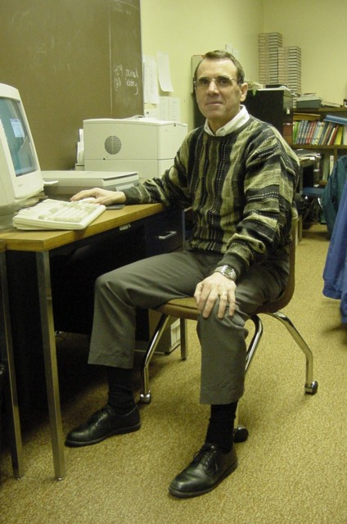

Jim Swift
Career background:
Jim began his career at Shabbona High School (1 year), Edward High School (2 years), and Schaumburg High School (1year) before joining HEHS for the past 29 years. He has taught PE, Driver’s Ed., coached cross country and track and has served as the Assistant Director of Transportation.

A highlight:
Qualifying for the state cross country meet for the first time in the school’s history in 1979 and winning the school’s first MSL conference championship in 1980.

Miss the most?
I’ll miss the relationships with the students and staff, seeing students who work hard achieve success. I’ll also miss all the activities and events that go on at a high school. It has also been a pleasure working with the great secretaries in 211.

Miss the least?
Form B self-evaluations, parent nights, institutes, excessive paper work, bells

Words of wisdom:
Being an educator is more demanding every year. Have passion, dedication, and enthusiasm for your job but don’t take yourself too seriously. Enjoy your career.

Retirement plans:
I’ll be staying in the area. Our family is planing a trip to Ireland in the summer of ’02.

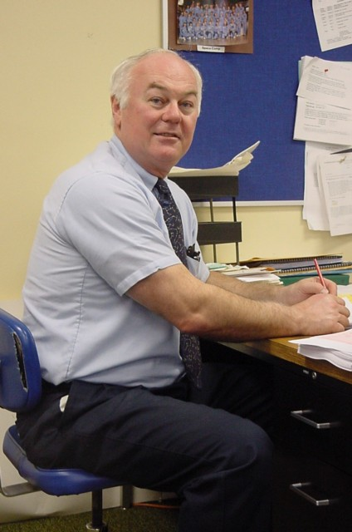

Will Vrba

Career background:
Will started in 1970 at Fremd High School where he taught P.E. and science and coached gymnastics, tennis, shot and discus. From 1973 until the present he has taught earth science, astronomy, geology and physical science. From 1973-1981 Will was the head coach of gymnastics and tennis and has been the assistant gymnastics coach from 1983 – 2002.

A highlight:
#1 – Earth Science Teacher of the Year – Washington D.C. 1983
#2 – Selected to Space Camp 2000
#3 – Selected to U.S.A. Today’s Teacher Team 2001

Miss the most?
The students and the staff

Miss the least?
All the administrative “stuff” and the block

Words of wisdom:
All the classes you have taken cannot prepare you for real life. Experience is your best teacher. Learn from your mistakes and do not be afraid to take risks.

Retirement plans:
Fishing, hunting, scuba diving, r/c flying, golfing, cruises, you know, all the “fun” things. A possible move to the Southwest when my wife retires.

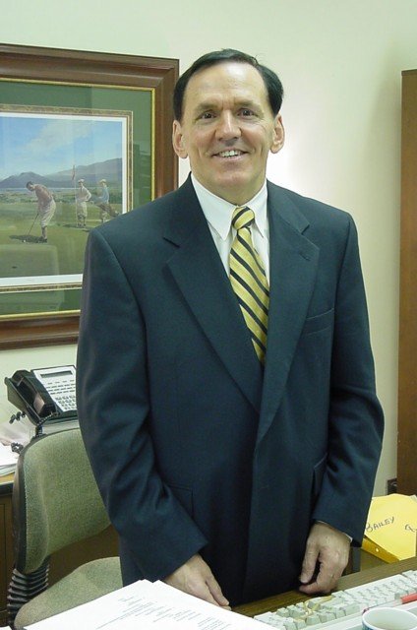

Dan Yokas

Career background:
Dan was a social studies teacher for 3 years in Independence, Iowa and served in the army for 2 years in Vietnam. He was a counselor for 23 years at HEHS and served as Student Services Director for 4 years. At HEHS he also coached wrestling, sponsored Freshmen Class and Junior Class.

A highlight:
The encouragement and support that was extended to me by faculty and staff when I assumed the role of Student Services Director.

Miss the most?
My involvement with young people. They continually offer a fresh perspective on life and they also keep us humble.

Miss the least?
I won’t miss the early start. It will be nice to stay in bed beyond 5:00 AM.

Words of wisdom:
Change is good. Embrace it.

Retirement plans:
No definite plans at the moment. I hope to do some traveling, but I definitely want to pursue other career interests as well.

